

Name: Biswajit Deb

Student ID: 20111000012828

Enrolment id: 2011200001018

Department: CSE (BTech) 3rd year

Semester: v

SE Assignment 1A

Q. 1. WASSIGNMENT-I (Project Scheduling: Activity Network & Gantt Chart)

(A) Consider the following activities of a proiect:

a) Specification

b) Design database

c) Design GUI part

d) Write user manual

e) Code database part

f) Code GUI part

g) Integrate and test

( 15days)

(45 days)

(30 days)

(60 days)

(105 days)

(45 days)

(12() days)

The following precedence relations hold among the tasks:

a<{b,c,d}; {b<e}; C<f; {e,f}<g.

Draw the Activity Network Diagram .Find out the following time parameter for each

job: ES, IS, EF, LF, ST & MT for the project

Draw the Gantt chart.

**Solution :**

**Table :**

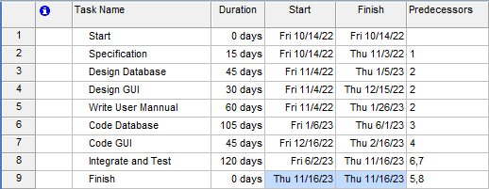

**Gantt Chart :**

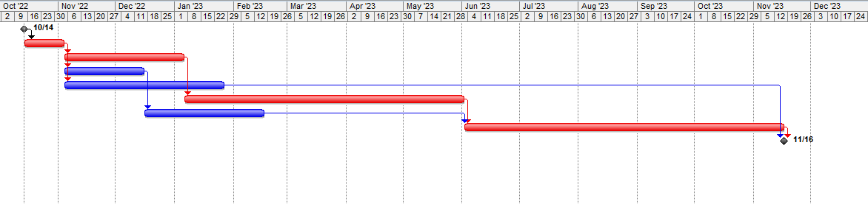

**Network Diagram :**

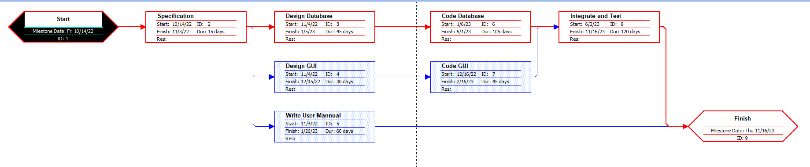

END